Software Design and Evaluation
For Two-wheel robot car Using Mbed.os

- Aim: Generate the code for automatic robot car with use of Mbed.os software

- Introduction:
- Software coding: Software coding is the process of translating computer instructions into a language that a computer can comprehend. Every website and application are usable because programmers create code. But you don't have to be an IT professional to use code.

- Code Evaluation: After a software developer has finished coding, it is important to conduct a code review to get a second perspective on the solution and implementation before it is merged into an upstream branch, such as a feature branch or the main branch. The reviewer could also be used as a second stage to look for bugs, logical mistakes, undiscovered edge circumstances, or other issues.

- How crucial is code evaluation?
The foundation for ongoing development and the prevention of the release of unstable code to users is laid by developing a trustworthy code review process. Code reviews should be implemented into the workflow process in order for a software development team to improve the quality of the code and ensure that every piece of code has been reviewed by another team member.
One objective of the code review process is to spread expertise inside an organization. According to 76% of developers that participated in the 2022 Global DevSecOps Survey, code reviews are "very valuable."

- Flowchart:
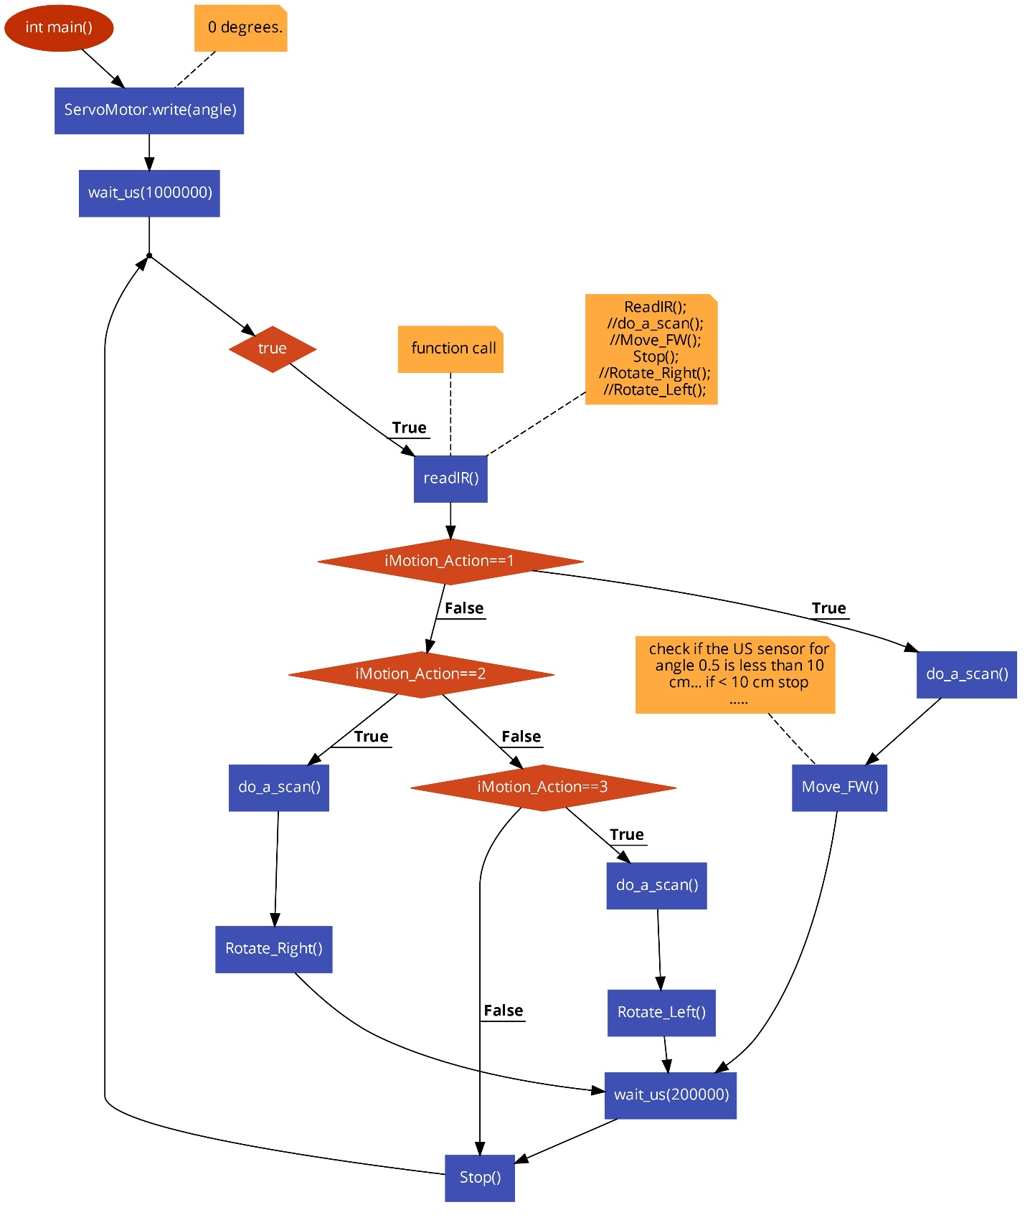

- Code and comment:
// Code for the UltraSound forward range detection

// Function to measure the distance using the UltraSound sensor and update the global variable
void USDistanceMeasure()
{
// Trigger the UltraSound sensor by sending a pulse
UltraSound.trigger();

// Measure the duration of the pulse and calculate the distance
int duration = UltraSound.pulse_duration();
float distance = duration / 58.0f;

// Check if the distance is within the allowable range and update the global variable
if (distance > 2.0f && distance < 400.0f)
{
UltraSoundDistance = (int)distance;
}
}
// Function to perform a scan using the UltraSound sensor and update the distance
void do_a_scan()
{
// Static variables to store the last 10 readings and the current index
static int readings[10];
static int index = 0;
int total = 0;
int average = 0;

// Call the USDistanceMeasure function to get the distance
USDistanceMeasure();
// Store the last 10 readings in an array and calculate the average distance
readings[index] = UltraSoundDistance;
index++;
if (index >= 10)
{
index = 0;
}
for (int i = 0; i < 10; i++)
{
total += readings[i];
}
average = total / 10;

// Print the distance to the console
printf("[US Sensor] The distance is %d\n", average);

// Move the servo motor to scan the area
if (!done)
{
if (direction == false)
{
angle += 0.1f;
if (angle > 1.0f)
{
direction = true;
}
}
else {
angle -= 0.1f;
if (angle < 0.0f)
{
direction = false;
done = true;
}
}
}
// Wait for 1 second before taking the next reading
wait_us(1000000);
}
- In this code, two functions are defined.
Through the use of an ultrasound sensor, the distance to an object in front of the device is measured by the function USDistanceMeasure(). A global variable (UltraSoundDistance) is then updated with the measured distance if the distance is found to be within a predetermined range.

do_a_scan() – This function uses the call to USDistanceMeasure() to obtain the distance and saves the most recent 10 readings in an array. The average distance is next calculated, and it is printed to the console. Along with scanning the area in front of it, the function also moves a servo motor and waits one second before taking the next reading. Angle, direction, and done variables govern the servo's movement.

- Test methodology:
A variety of testing approaches can be used to test this code. Here are a few diagrams:

1 Unit testing is the process of testing particular variables or strategies separately from the rest of the code to ensure that they operate as intended. Unit tests might be implemented, for example, to ensure that USDistanceMeasure() and do_a_scan() accurately compute the average distance and control the servo motor.

2 Integrity testing involves examining how different pieces of code interact with one another. In order to ensure that USDistanceMeasure() updates the UltraSoundDistance variable appropriately and that do_a_scan() uses it correctly to calculate the average distance, for instance, integration tests could be implemented.
3 To make sure the system operates as intended and meets all requirements, system testing necessitates subjecting the entire system to testing. We might test the entire system, for example, by constructing a real setup with an ultrasonic sensor and a servo motor, running the code on the proper platform, and verifying that it successfully executes scans and predicts distances.

4 Regression testing: This refers to testing the code again after modifications have been made to ensure that its functionality continues to function as intended. If the do_a_scan() function, for example, is changed, we should re-run the unit and integration tests to ensure that the changes did not introduce any regressions or new problems.

5 Acceptance testing is the process of testing the code in compliance with the requirements and expectations of the user. We might perform acceptance testing to check, for instance, that the system satisfies the user's requirements for accuracy, speed, and comfort of use. To do this, it could be necessary to develop test cases and scenarios with the end users and assess how well the system works in actual situations.

- Conclusion:
The robot's movements are made possible by the sensors. The robot can avoid collisions thanks to the HC-SR04 ultrasonic sensor. This sensor allows the robot to avoid it. And with the help of IR sensors, the black path advances.

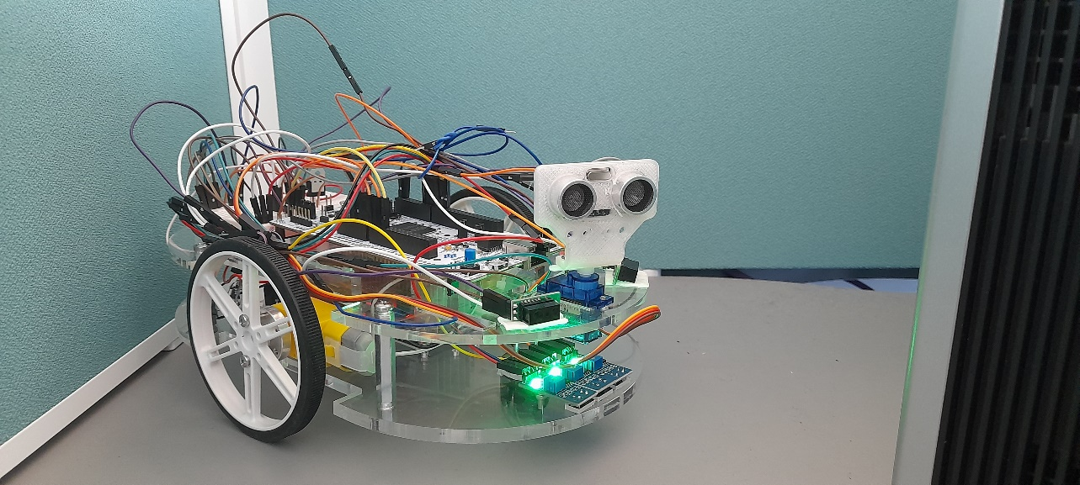
- Some images of Robot car
